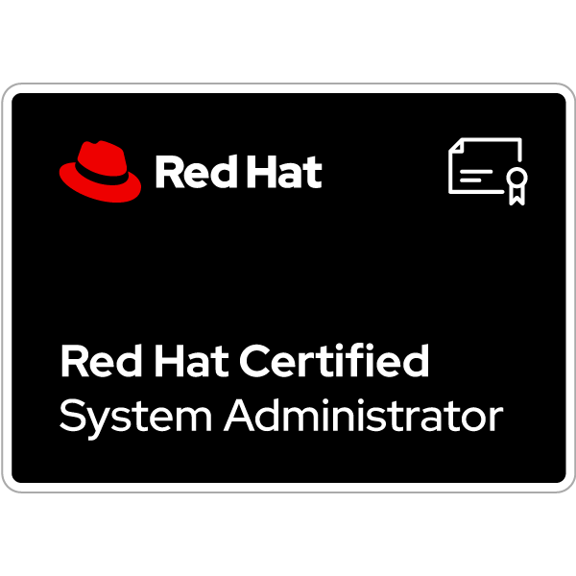**Yogita Sandip Hodgar**

**E-Mail:** **hodgaryogita@gmail.com**

**Contact:+ 91-9529912598**

To be in a professional environment with growing opportunities and a challenging job profile through hard work and dedication. I am self-motivated, enthusiastic,quick learner.I,working with teams. I have the ability to innovate and adapt to new situations.Resourceful and committed to increase my knowledge of relevant technologies.

**Professional Preface**

* A competent professional with **3 Years** of experience in System Administrator, Linux Administrator and Production support Linux,SQL

**Employment Scan**

**Oct-2020 to Till Date – Om Consultancy Pvt Ltd – System Administrator**

**Roles and Responsibilities:**

# Providing Remote LINUX System Administration of Red Hat Linux in 24x7 support services.

# Providing support for all types of OS auto-generated LINUX issues.

# Monitoring System Performance of Virtual memory, Swapping, Disk utilization and CPU utilization.

# Creation and Managing Users / Group accounts and set up a user's work environment. .

# Scheduling of automatic, repetitive Jobs using commands with Crontab. • Providing Crontab access to the application users.

# 

# Changing File Permissions and providing special file permissions (Sticky Bit, Set UID, Set GID).

# 

# Process Administration and management like monitoring, stop/start/kill various processes.

# 

# Applying Patches, packages, software installations and upgrades.

# Working on various server down alerts and bringing them up ASAP.

# YUM client/server configuration.

# 

# Creation of logical volumes and mounting the file systems.

# Maintaining file systems: Checking and repairing file systems and monitoring file system usage. .

# Experience in virtual host configuration in the APACHE web server.

# 

# Working on all the kinds of auto generated and User generated tickets.

# Coordinating with Vendors/Hardware teams and Servers, Owners for a mutually agreeable time for resolving issues when necessary.

# Administering and monitoring System Performance.

* Role Very Excellent hands on experience in all Linux Commands.
* Monitoring the Health and Stability of Linux System environments.
* Diagnosed and resolved problems associated with DNS, APACHE.

* Installation & configuration of services like NFS, Web Server.
* .
* Manage file and system security using SELINUX, ACLS and permissions.
* Hands on experience of disk partitioning and mounting of file systems.
* Having Knowledge about MYSQ.
* File System Creation with LVM, File System increase, Linux Patch Management .
* Monitored network traffics and troubleshoot network issues.
* Monitoring and maintaining the Error Logs .

# Management of Hard Disk Drives on the server & Disk Partitioning

# Managing permissions of files and directories.

# 

# Troubleshooting of various services like SSH, FTP on Linux platform like Red Hat.

# Worked onDNS, NFS, NTP, FTP, SSH, SCP .

* Administration, Troubleshooting and Maintenance of Linux servers.

.

* Client Interaction.
* Having Knowledge about AWS.

.

# 

**IT Proficiency Skills.**

* **Operating System**:Linux, UNIX. Windows,
* **Database:** MySQL,
* **Cloud:** AWS

**Certification-** Redhat Certified System Administrator

[**https://www.credly.com/badges/0edc25e8-14b4-4b72-9c5b-1d9eedbd95b2/public_url**](https://www.credly.com/badges/0edc25e8-14b4-4b72-9c5b-1d9eedbd95b2/public_url)

**Academic Credentials-**

* **Bachelor of Art** 2015 with 60%
* **HSC (12th) Board of Higher Secondary Education, Maharashtra** State Board 2008 with 55.00%
* **SSC (10th) Board of Secondary Education from** Maharashtra,State Board 2006 with 60.00 %

**Personal Dossier**

**Name: Yogita Sandip Hodgar**

**Date of Birth:** 31 /5/1990

**Linguistic Abilities:** English, Hindi and Marathi

**Address:Shevale vasti,orient park gate no.1,Bhagirathi nagar,sade satra nali, Hadapsar, 411028**.